Intro to Radar Systems HW3

1. PFtotal = ( PFmulti + PFatmo ) / # of <> = 0.913
2. Arain = 2 · 1 = 2 dB, Afog = 2 · 0.35 = 0.7 dB, Aclear = 1 · 0.3 = 0.3, Atotal = 3dB

3.

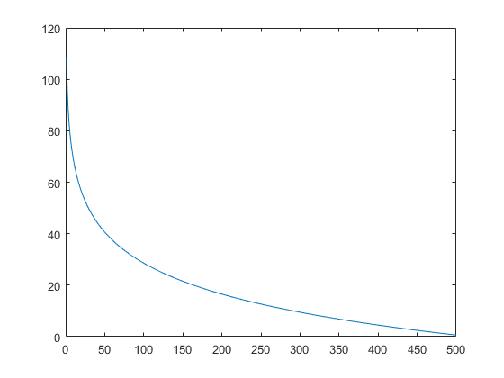

4.

